3.3 Game Management Subsystem Interface
Game management Subsystem Interface, our controller objects are combined to manage the actual game dynamics and game logic. We have 6 classses and we have just one controller class and other classses are property classses. In Figure-1, controller class can be seen and setting and GameInfo are subclasses of the Controller and Runnable,KeyListener and MouseListener are interface.
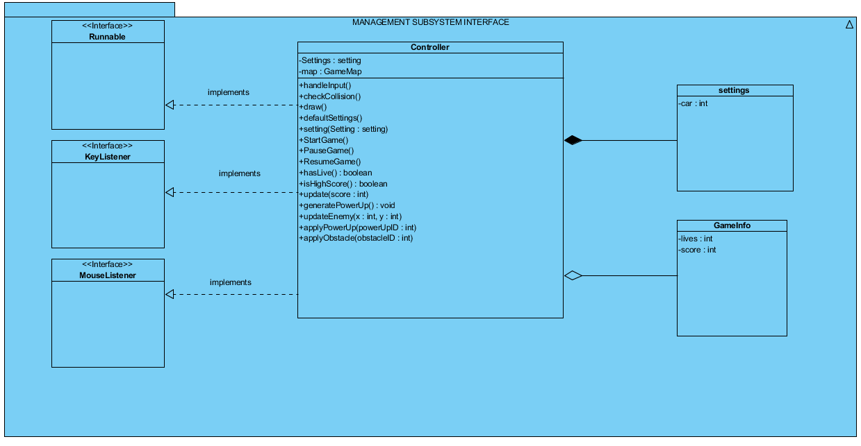

Figure-2( GameManagement Subsystem Interface )

Controller Class
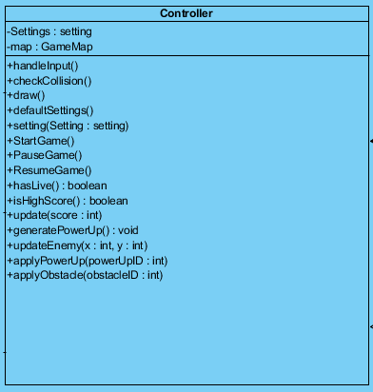
This class is the Façade class of the GameManagement subsystem. User Interface subsystem send some requests and according the these requests, it performs operations properly and this class implements runnable interface which provides running the game loop as a thread.

Attributes:
private Setting settings: this attribute provides holding settings of the game, like car type so user can play his/her car which he select in the beginning of the game.
private GameMap map: this attribute is a map object, controller class associates with proper methods of GameMap class.

Methods:
public boolean handleInput(): it checks the user playing, in the playing, it checks that user can whether the obstacle or not.
public boolean checkCollision(): it checks the wheter the car crash with other enemy car or obstacle. If it does, it returns true, otherwise false and his/her score is increases.
public void draw(): it provides the drawing the enemies and other obstacles during the game and add them the main frame.
public void defaultSettings(): it resets the all settings which is set by user and it restore all settings.
public Setting setting(): it enables possibility of choosing the settings in the beginning of the game.
public void StartGame(): it starts the new game and all of the old game are not stored so all game which are played are deleted.
public void PauseGame(): it poused the game so Timer in the code stops so user see the panel which has label is naming as Continue if he/she want to continue, should click it and Timer starts again.
public void ResumeGame(): after the pousing, it provides continutiy for the user so user can resumer the game remaining of his game.
public boolean hasLive(): it checks the user live during all the game and if it returns true, user can continue the game but if it returns false,user will see another screen.
public boolean isHighScore(): In the game all scores are saved but it is for just one play so while user is playing the game, this method checks his/her score and compare with his/her other scores.
public void update(): update the game while user are playing it but it just for his/her score because for power-ups and enemies updating, game has another methods.
public void generatePowerUp(): it generates the power-ups. In the game user can find different power-ups so we should generate them, this method provides it.
public void updateEnemy(): it generates the enemies. We have not one type enemies. Therefore in the game user can see different enemies so like power-ups we should generate them, this method provides it.
public void applyPowerUp(): After generating power-ups, it applies the given power-ups to the system.
public void applyObstacle(): After generating obstacles, it applies the given obstacle to the system.
Listener Classes
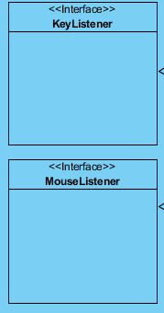
These class are designed to detect user actions while he/she are playing the game. Our game is played by using keyboard so we need the take user action by using KeyListener class so if user want to exit or pause the game, he/she should use the mouse so we need also MouseListener class and moreover user needs to use mouse in the beginning of the game.
Setting Class
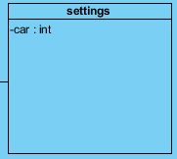
Setting class provides settings car number in the game,actually we can named it as a difficulty of the game because in the game, user can set the number of cars in the game and if car number is more, game would be more difficult.
GameInfo Class
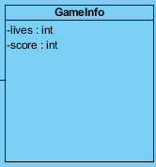
GameInfo class gives some information about players gaming. One of them is his/her remainning live and other one is score. So thanks to the this class, user can learn remainning lives and score and he/she does not need to exit the game if he/she click the gameInfo, he/she will learn.

